Help WF – Como ativar para mostrar o fluxo de workflow no botão GOS?
Exemplo na transação WCOCO, que mostra liquidação de contrato.
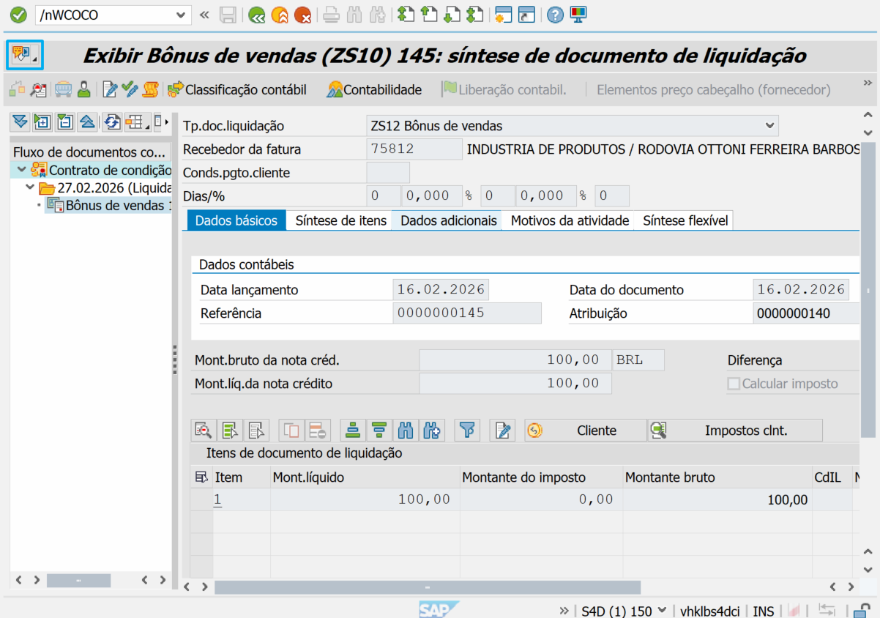
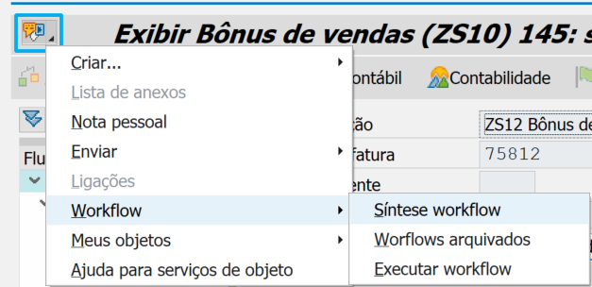

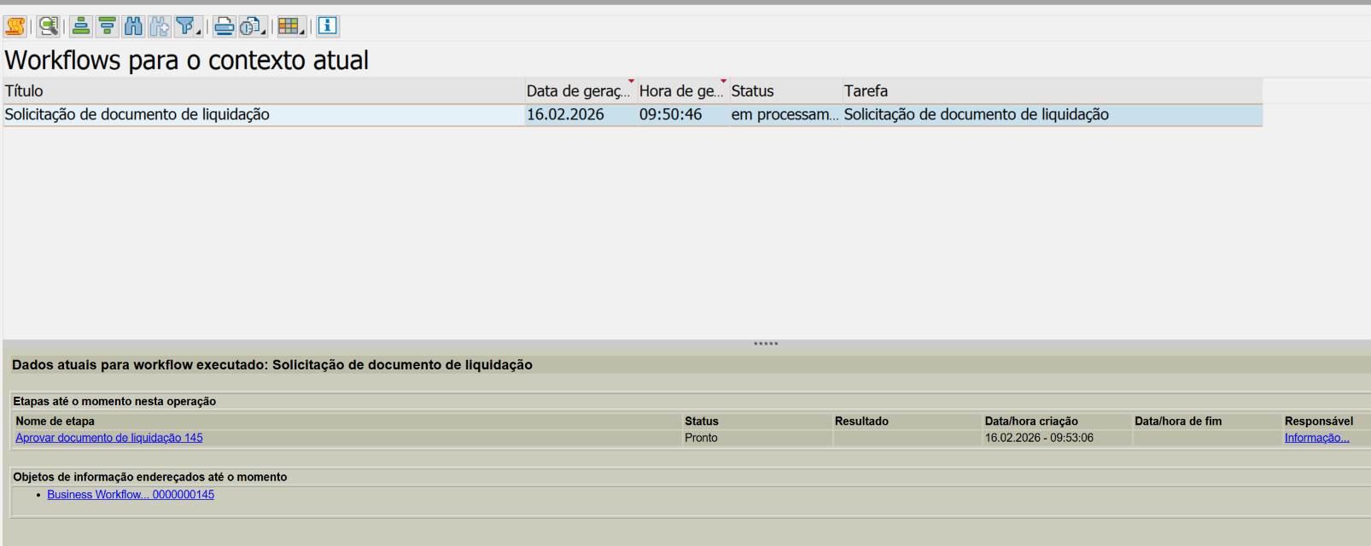

BADI GOS_MULT_PUBLISH
Adicionar filtro WF_OVERVIEW
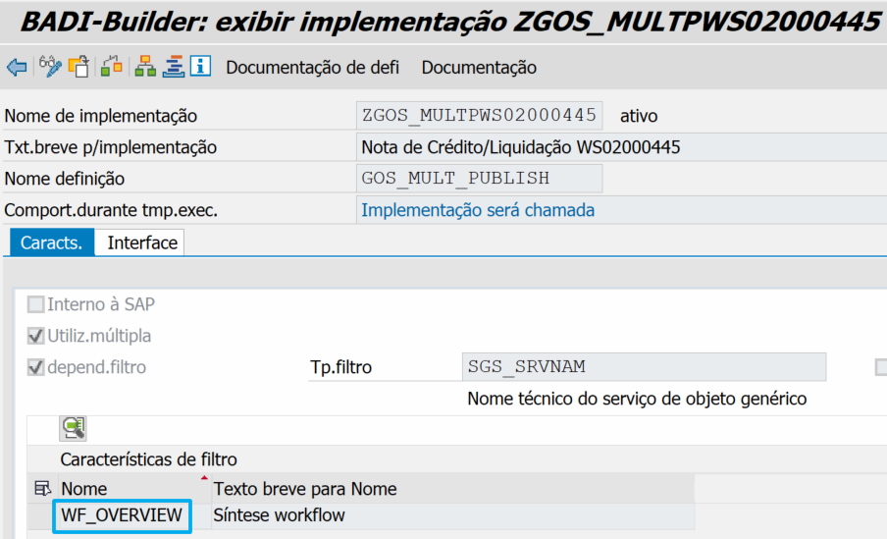

Codificação
METHOD if_ex_gos_mult_publish~add_objects.
FIELD-SYMBOLS: <fs_lporb> TYPE sibflporb,
<fs_new> TYPE sibflporb.
DATA: lv_instid TYPE sibfboriid.
LOOP AT ct_lporb ASSIGNING <fs_lporb> WHERE catid = 'BO' AND
typeid = 'BUS2100002'.
"map key from FIPP (BUKRS,BELNR,GJAHR) to (BELNR,BUKRS,GJAHR)
“CONCATENATE
“ <fs_lporb>-instid+04(10) "BELNR
“ <fs_lporb>-instid+00(04) "BUKRS
“ <fs_lporb>-instid+14(04) "GJAHR
“INTO lv_instid RESPECTING BLANKS.
lv_instid = <fs_lporb>-instid.
APPEND INITIAL LINE TO ct_lporb ASSIGNING <fs_new>.
<fs_new>-instid = lv_instid.
<fs_new>-catid = 'CL'.
<fs_new>-typeid = 'CL_WLF_BWF_DOCUMENT_UPDATES'.
ENDLOOP.
SORT ct_lporb.
DELETE ADJACENT DUPLICATES FROM ct_lporb.
ENDMETHOD.

